
MATHEMATICS DEPARTMENT
Year 12 SPECIALIST MATHEMATICS
TEST 3: INTEGRATION
DATE: 6th April 2016 Name____________________________________
Reading Time: 3 minutes
SECTION ONE: CALCULATOR FREE
TOTAL: 35 marks
EQUIPMENT: Pens, pencils, pencil sharpener, highlighter, eraser, ruler, SCSA formula sheet.
WORKING TIME: 35 minutes (maximum)
SECTION TWO: CALCULATOR ASSUMED
TOTAL: 19 marks
EQUIPMENT: Pens, pencils, pencil sharpener, highlighter, eraser, ruler, drawing instruments, templates, up to 3 Calculators,
1 A4 page of notes (one side only), SCSA formula sheet.
WORKING TIME: 20 minutes (minimum)
SECTION 1  Question | Marks available | Marks awarded | SECTION 2  Question | Marks available | Marks awarded
1 | 10 |  | 6 | 5
2 | 8 |  | 7 | 6
3 | 4 |  | 8 | 8
4 | 6
5 | 7
Total | 35 |  |  | 19

Calculator-free [35 marks]
This paper has Five (5) questions. Answer all questions. Write your answers in the spaces provided

Question 1 [10 marks]

Determine the following indefinite integrals.

- [3]

- [3]

- [4]

Question 2 [8 marks]

Evaluate:

- [3]

- [5]

Question 3 [4 marks]

The curves below areand. Determine the area of the shaded region.
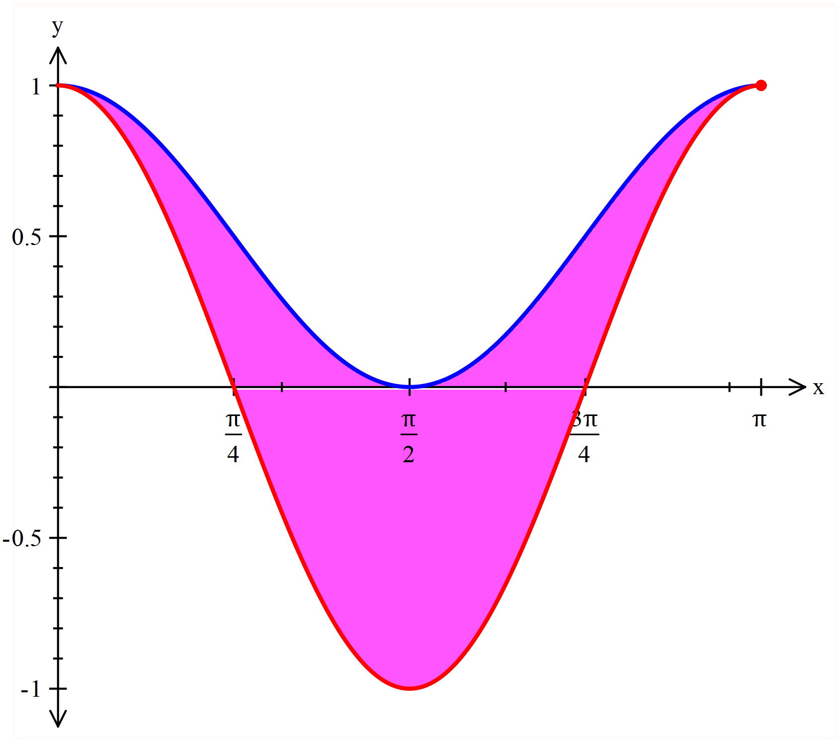

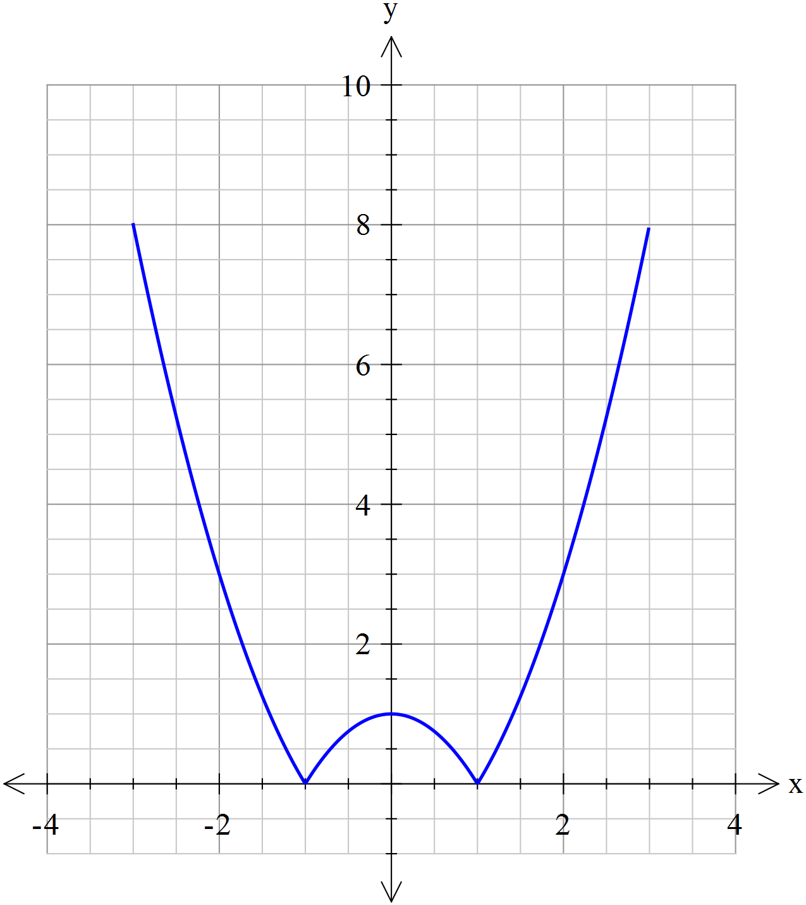Question 4 [6 marks]

A glass is formed by rotating the function about the y-axis as shown in the diagram.

- Complete the middle line for the piecewise function for .

[1]

- Given the height of the glass is 8 cm determine the volume of the glass. [5]

Question 5 [7 marks]

Find using the substitution x = 2 sin θ.

NAME:……………………………………………………………………………………
Calculator Allowed 20 minutes [19 marks]
This paper has Three (3) questions. Answer all questions. Write your answers in the spaces provided

Question 6 [5 marks]
Determine the value of p in the system of linear equations below such that there is
- no solution [3]

- a unique solution [1]

- infinitely many solutions [1]

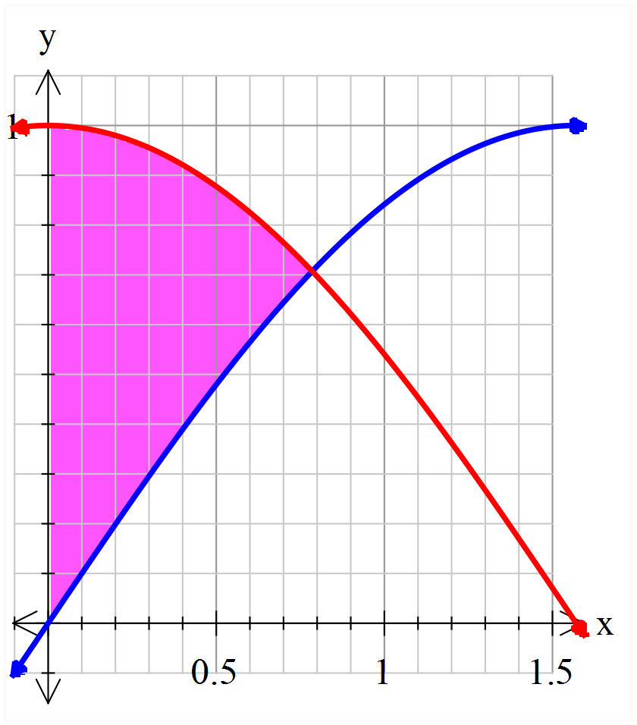Question 7 [6 marks]

The graph at the right show the curves and .
- Prove that the intersection of and , is
for the domain .

[1]

- Determine the exact area of the region (shaded) which is bounded by the y-axis and the curves
and. [2]

- Determine the volume of revolution obtained when this area is rotated about the x-axis. [3]

Question 8 [8 marks]
- Use the identity to prove that [2]

- Find a similar expression for [2]

- Hence show that [4]

END OF QUESTIONS

